Project Title:

WebScanPro : Web Application Security Testing Tool

Objective:

.The objective of Week 1 was to:

.Define the project goals and expected outcomes.

.Set up a local testing environment.

.Deploy an intentionally vulnerable web application.

.Explore the structure and potential security flaws manually.

Project Goal

.To develop an automated web application security testing tool using Python that can detect common vulnerabilities such as:

.SQL Injection

.Cross-Site Scripting (XSS)

.Broken Authentication

.Insecure Direct Object References (IDOR)

Tools Used in Week 1

Tool Purpose

XAMPP Local server environment (Apache + MySQL)

DVWA Vulnerable web application for testing

VS Code Development environment

Python Programming language for scanner development

Environment Setup

.1️⃣ Installing XAMPP

. Installed XAMPP for Windows.

. Started Apache and MySQL services.

. Verified setup using:

. http://localhost

2️⃣ Deploying DVWA

. Copied DVWA folder into:

. C:\xampp\htdocs\

. Accessed DVWA using:

. http://localhost/dvwa

. Created/reset database.

Logged in using default credentials:

Username: admin

Password: password

Set DVWA security level to LOW for testing.
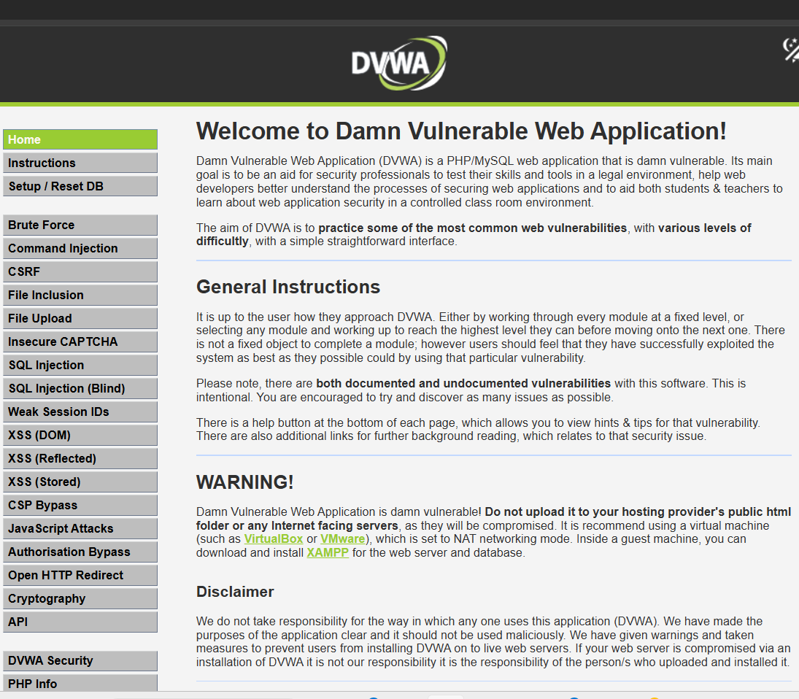🔎 Manual Exploration of DVWA
The application was manually explored to understand:
Available modules
URL structures
Input fields
Form submissions
Query parameters (e.g., ?id=1)
Identified Vulnerable Modules:
SQL Injection
Reflected XSS
Stored XSS
Brute Force
Command Injection
File Upload
Outcome of Week 1
. Successfully set up a local testing environment.
. Understood the structure and behavior of a vulnerable web application.
. Identified potential injection points for automated testing.
. Prepared the foundation for scanner development.
week-2
Project Structure (Week-2)
├── main.py
├── crawler.py
└── scan_results.txt (auto-created)
1️⃣ crawler.py (Target Scanning Module)
->This file contains the crawler logic.
Program : -
import requests
from bs4 import BeautifulSoup
from urllib.parse import urljoin
def crawl(url):
print(f"\nScanning Target: {url}\n")
try:
response = requests.get(url)
soup = BeautifulSoup(response.text, "html.parser")
with open("scan_results.txt", "w") as file:
file.write("=== WebScanPro Target Scan Results ===\n\n")
file.write("Links Found:\n")
print("Links Found:")
for link in soup.find_all("a"):
href = link.get("href")
if href:
full_url = urljoin(url, href)
print(full_url)
file.write(full_url + "\n")
file.write("\nForms Found:\n")
print("\nForms Found:")
for form in soup.find_all("form"):
form_details = str(form)
print(form_details)
file.write(form_details + "\n")
print("\nScan completed. Results saved in scan_results.txt")
except Exception as e:
print("Error occurred:", e)
2️⃣ main.py (Program Entry Point)
->This file runs the crawler.
from crawler import crawl
if __name__ == "__main__":
target_url = http://localhost/dvwa/
crawl(target_url)
3️⃣ Command You Executed
. In VS Code terminal:
python main.py
What This Code Did (Week-2 Purpose)
✔ Connected to DVWA
✔ Downloaded webpage HTML
✔ Extracted all links
✔ Extracted all forms
✔ Printed them in terminal
✔ Saved results to scan_results.txt
Example Output (scan_results.txt)
=== WebScanPro Target Scan Results ===
Links Found:
http://localhost/dvwa/login.php
http://localhost/dvwa/vulnerabilities/sqli/
http://localhost/dvwa/vulnerabilities/xss_r/
Forms Found:
<form action="login.php" method="post">
...
What You Completed in Week-2
->You successfully implemented:
. HTTP communication
. HTML parsing
. Link discovery
. Form extraction
. Metadata storage
. This completes : Target Scanning Module

